|  |  |
| --- | --- |
| DATE | 22-11-2022 |
| TEAM ID | PNT2022TMID41534 |
| PROJECT NAME | AI-POWERED NUTRITION ANALYZER FOR FITNESS ENTHUSIASTICS |

# CLOUD DEPLOYMENT

With cloud computing, we have access to a pool of shared computer resources (servers, storage, software, etc.). All you have to do is ask for more resources when you need them. The clouds make it simple to swiftly start up resources. Resources that are no longer required can be released. You can use this strategy to only pay for what you actually use. All maintenance is handled by your cloud provider. Depending on how much data you want to store and who has access to the infrastructure, it operates as a virtual computing environment with a deployment architecture that varies.

# Deployment Models

Based on ownership, scale, access, and the nature and purpose of the cloud, the cloud deployment model pinpoints the precise sort of cloud environment. A cloud deployment model specifies the location and ownership of the servers you're using. It details your cloud infrastructure's appearance, what you can adjust, and whether you'll receive services or have to build everything from scratch. The forms of cloud deployment also determine the connections between your users and the infrastructure.

Different types of cloud computing deployment models are:

1. Public cloud
2. Private cloud
3. Hybrid cloud
4. Community cloud
5. Multi-cloud

Let us discuss them one by one:

# Public Cloud

Using the public cloud, anyone can access systems and services. Given that everyone can use the public cloud, it might be less secure. The public cloud is one where cloud infrastructure services are made available to the general public or significant industry groups over the internet. In this cloud model, the provider of the cloud services, not the user, is the owner of the infrastructure.

Customers and users can access systems and services with ease thanks to this kind of cloud hosting. This type of cloud computing is a great illustration of cloud hosting, where service providers offer services to a range of clients.

Storage backup and retrieval services are provided in this arrangement either for free, on a subscription basis, or on a per-use basis. For instance, Google App.

# Advantages of the public cloud model:

* + **Minimal Investment:** Pay-per-use means there is no significant upfront cost, which makes it ideal for businesses that need immediate access to resources.
  + **No setup cost:** There is no need to install any hardware because the cloud service providers fully fund the infrastructure.
  + **Infrastructure Management is not required:** Infrastructure management is not necessary when using the public cloud.
  + **No maintenance:** The service provider does the maintenance work (Not users).
  + **Dynamic Scalability:** On-demand resources are available to meet the needs of your business.

# Private Cloud

The public cloud deployment model contrasts sharply with the private cloud deployment model. It's a private setting for only one user (customer). Sharing your hardware with others is not necessary. In how you manage all of the hardware, private and public clouds differ from one another. It also goes by the name "internal cloud," and it describes the capability of accessing systems and services inside a specific business or boundary. The cloud platform is put into use in a highly secure environment that is hosted in the cloud, guarded by robust firewalls, and managed by an organization's IT department.

Greater flexibility and control over cloud resources are provided by the private cloud.

# Advantages of the private cloud model:

* + **Better Control:** The property has only you as its owner. You acquire total control over user behavior, IT operations, and service integration.
  + **Data Security and Privacy:** It is appropriate for holding corporate data to which only authorized employees have access. Access and security can be improved by dividing up resources within the same infrastructure.
  + **Supports Legacy Systems:** This approach is designed to work with legacy systems that are unable to access the public cloud.
  + **Customization:** Unlike a public cloud deployment, a private cloud allows a company to tailor its solution to meet its specific needs.

# Hybrid cloud

Hybrid cloud computing combines the best of both worlds by creating a barrier between the public and private realms using a layer of proprietary software. By using a hybrid solution, you may host the app in a secure location and benefit from the financial advantages offered by the public cloud. Depending on their needs, organisations can use a combination of two or more cloud deployment methods to move data and applications between various clouds.

# Advantages of the hybrid cloud model:

* + **Flexibility and control:** Businesses with more flexibility can design personalized solutions that meet their particular needs.
  + **Cost:** Because public clouds provide for scalability, you’ll only be responsible for paying for the extra capacity if you require it.
  + **Security:** Because data is properly separated, the chances of data theft by attackers are considerably reduced.

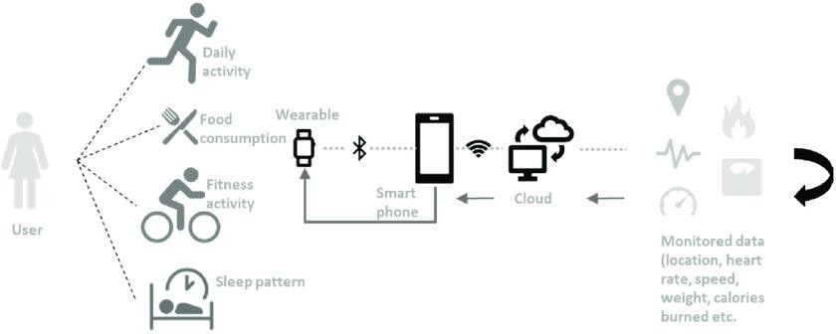

# Community cloud

Hybrid cloud computing combines the best of both worlds by creating a barrier between the public and private realms using a layer of proprietary software. By using a hybrid solution, you may host the app in a secure location and benefit from the financial advantages offered by the public cloud. Depending on their needs, organizations might use a combination of two or more cloud deployment methods to move data and applications between various clouds.

# Advantages of the community cloud model:

* + **Cost Effective:** It is cost-effective because the cloud is shared by multiple organizations or communities.
  + **Security:** Community cloud provides better security.
  + **Shared resources:** It allows you to share resources, infrastructure, etc. with multiple organizations.
  + **Collaboration and data sharing:** It is suitable for both collaboration and data sharing.

# Multi-cloud

We’re talking about employing multiple cloud providers at the same time under this paradigm, as the name implies. It’s similar to the hybrid cloud deployment approach, which combines public and private cloud resources. Instead of merging private and public clouds, multi-cloud uses many public clouds.

Although public cloud providers provide numerous tools to improve the

reliability of their services, mishaps still occur. It’s quite rare that two distinct clouds would have an incident at the same moment. As a result, multi-cloud deployment improves the high availability of your services even more.

# Advantages of a multi-cloud model:

* + You can mix and match the best features of each cloud provider’s services to suit the demands of your apps, workloads, and businessby choosing different cloud providers.
  + **Reduced Latency:** To reduce latency and improve user experience, you can choose cloud regions and zones that are close to your clients.
  + **High availability of service:** It’s quite rare that two distinct clouds would have an incident at the same moment. So, the multi-cloud deployment improves the high availability of your services.